## 2.4 State of Health (SOH)

**2.4.1 Feature Objective:**

A battery’s condition is called its state of health (SOH). Batteries start their life with 100% SOH and over time they deteriorate because of chemical reactions during charging and discharging process. SOH is an estimation of the useful life of the battery base on some battery internal variables, such as battery cell internal resistance, SOC and open circuit voltage. SOH allows user to constantly track the battery status and plan for possible battery replacement. More importantly, it is also useful to predict total energy that can be consumed, which, in turn, can be employed to determine vehicle travel range and for better energy management within the vehicle control.

**2.4.2 Functional Description:**

There are mainly two approaches to estimate SOH: One is to estimate the internal equivalent series resistance (ESR) of battery and the other is to estimate the capacity of the battery. In this project, we will use the first approach because of the following considerations. Firstly, as the battery ages, its equivalent series resistance increases due to unwanted side reactions and structural deterioration, which put ESR as a good indicator of SOH. Secondly, an up-to-date knowledge of ESR is important to estimate state of power and current limit calculation. Lastly, the estimation of ESR is easy to implement that does not incur much computation and memory cost.

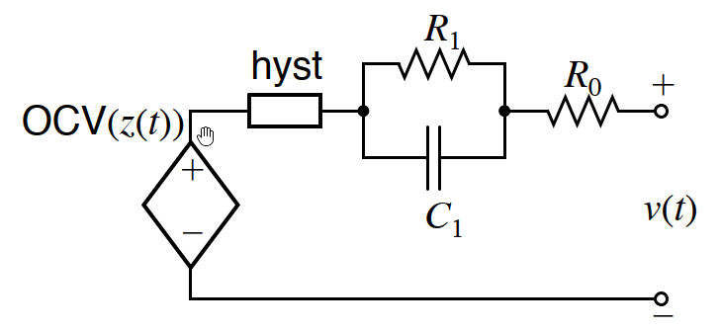

Figure 2.3.1 Equivalent Circuity

To compute variation of the ESR, we can use the self correcting battery cell model shown in Figure 2.3.1. The battery voltage can be estimated by:

$v\left(k\right)=OCV\left(z_{k}\right)+Mh_{k}-\sum_{i}^{n}{R_{i}i_{R_{i},k}}-i_{k}R_{0}$ (2.3.1)

where $OCV\left(z_{k}\right)$ is the open circuit voltage at time k, $Mh_{k}$ is the hysteresis voltage, $i_{R_{i},k}$ is the diffusion voltage, $i_{k}$ is the battery current and $R_{0}$ is the internal resistance. Since $i_{k}$ can be very large, the absolute sensitivity is high from $R_{0}$ to $v\left(k\right)$. We can then estimate the internal resistance by comparing the voltage at two adjacency time samples:

$v\left(k\right)=OCV\left(z_{k}\right)+Mh_{k}-\sum_{i}^{n}{R_{i}i_{R_{i},k}}-i_{k}R_{0}$ (2.3.2)

$v\left(k-1\right)=OCV\left(z_{k-1}\right)+Mh_{k-1}-\sum_{i}^{n}{R_{i}i_{R_{i},k-1}}-i_{k-1}R_{0}$ (2.3.3)

Since hysteresis term, diffusion term and open circuit term change relatively slow compare to how quickly $i_{k}$ change, so we can arrive at

$v_{k}-v_{k-1}≈R_{0}\left(i_{k-1}-i_{k}\right)$

from which we can estimate

${\hat{R}}_{0,k}=\frac{v_{k}-v_{k-1}}{i_{k-1}-i_{k}}$ (2.3.4)

Note that we compute ${\hat{R}}_{0,k}$ only when $|∆i_{k}|$ is large enough to avoid noise effects on this computation. Because of the inaccuracy introduced through battery model, the estimation ${\hat{R}}_{0,k}$ might be noisy. We can apply a simple filter to the noisy signal to obtain the estimate as

${{\hat{R}}_{0,k}^{filt}={\hat{R}}_{0,k-1}^{filt}+(1-α\hat{)R}}_{0,k}$,

where $0≪α<1$.

* **Resistance as function of SOC and Temperature**: Note that to compare with the nominal internal resistance, we will use the internal resistance table as a function of SOC and temperature. The table would eliminate the estimation bias introduced by those two factors if we use constant nominal internal resistance.

**2.4.3 I/O description:**

The SOH module requires the dynamic I/O shown in the following table

|  |  |  |  |
| --- | --- | --- | --- |
| **Signal(s)** | **I/O** | **Description** | **Units/comments** |
| soh_ChargingStatus | Input | battery charging status | unitless |
| soh_DisChargingStatus | Input | battery discharging status | unitless |
| soh_PackCurrent | Input | pack current input from VITM feature | A |
| soh_CellVoltage | Input | cell voltage input from VITM feature | V |
| soh_CellTemp | Input | An estimate of available pack charge power | °C |
| soh_CellSOC | Input | An estimate of available discharge current | unitless |
| soh_index | Output | An estimate of state of health | unitless |